HOW TO USE ERPROJECT

Step 1: First you need to have a sublime text software

Step 2: Embed the folder in the sublime text editor with the open folder option as shown below.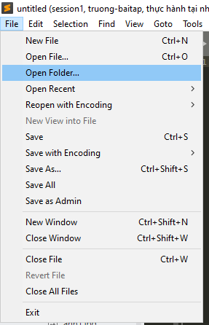

Step 3: After embed the folder, the sublime text editor screen will look like below.

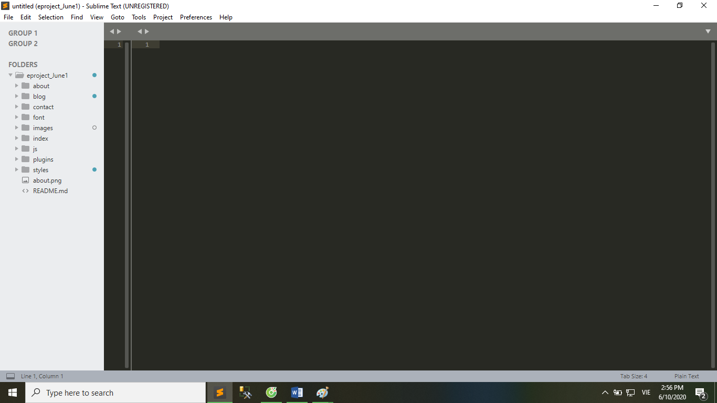

You can select the file you want to open from the list displayed on the left side of the screen, as shown in the image below.

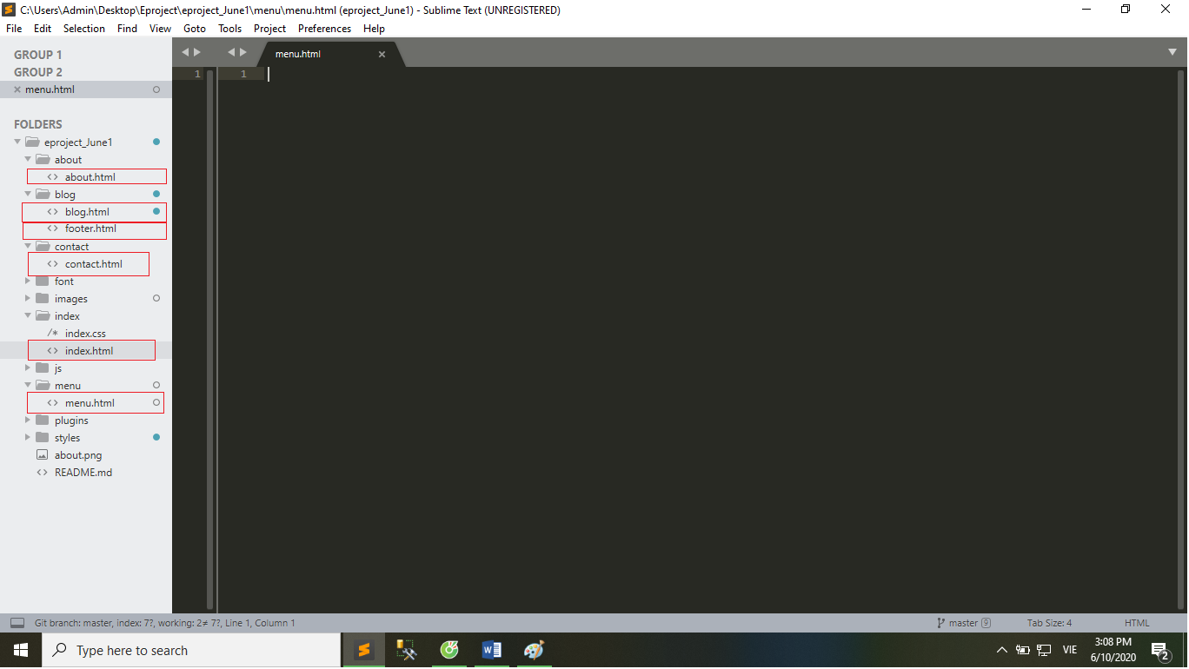

Note that the color combination helps identify the keywords and packages included in the code

To access the home page, select the index.html file in the index folder, right click as shown below.

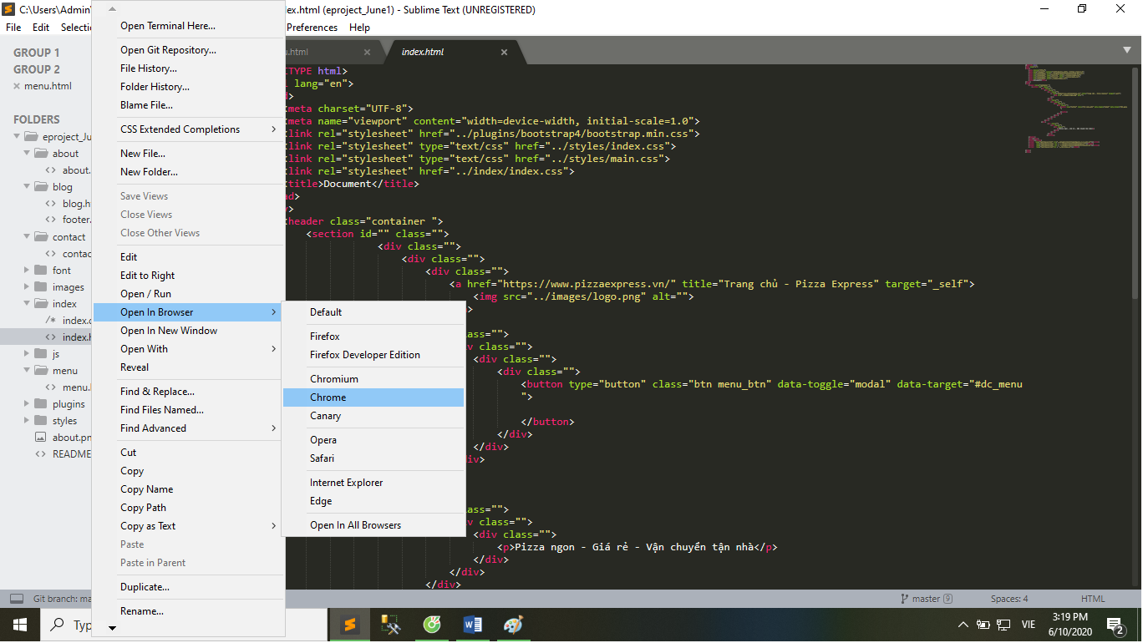

Here we choose the default browser is chrome.

Then the homepage is displayed.



 Or open from sublime text similar to how to access the homepage via the index.html file.

You can change the logo as you like.



By changing the logo1.png image in the images folder.

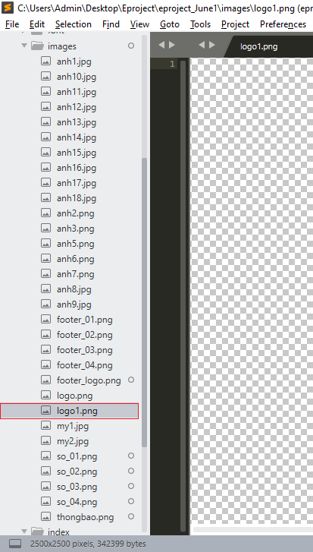

In the contact page you can change the map position as you like.



By changing the following parameters.

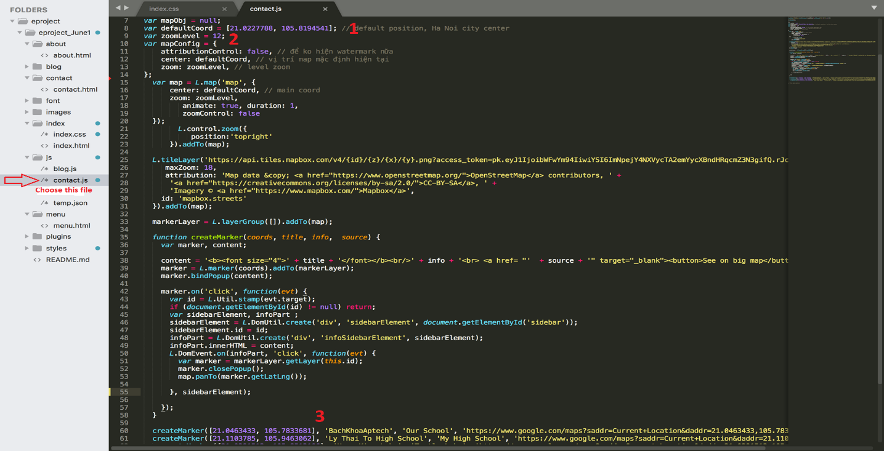

Note :

1: Central position of the map.

2: zoom level of the map.

3: optional parameters.

Optional parameters included:

1. Coordinates marker
2. Marker name
3. Related information.
4. Link coordinates marker in Google Maps

The End

Through the above instructions we hope to bring you the best experience. Send feedback to Email: ngovietanh2000@gmail.com